



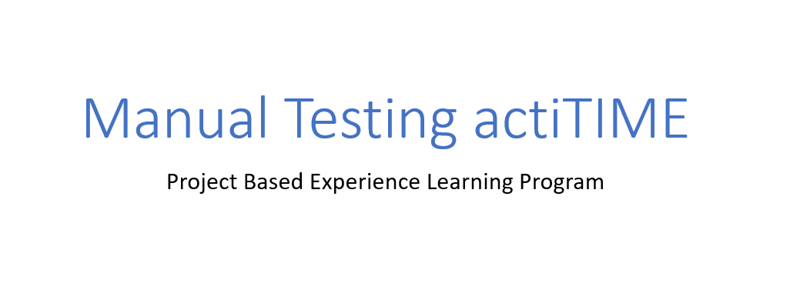



Project submitted:

Team leader :Yediri Tulasi

Team member: Ankamreddi Rajkumar

Team member: Gorli Hyma

Team member: Duri Durgaprasad

actiTIME Manual Testing

actiTIME is a website deals with product for Time Tracking Software for cost-effective projects. actiTIME boosts performance, track work progress and don’t leave any billable second untracked and records billable hours for a project resource for easy monitoring the work hours.

we can generate reports based on hours logged and also, we can integrate with other platforms like google calendar ,Zapier etc.

# actiTIME HOME PAGE:

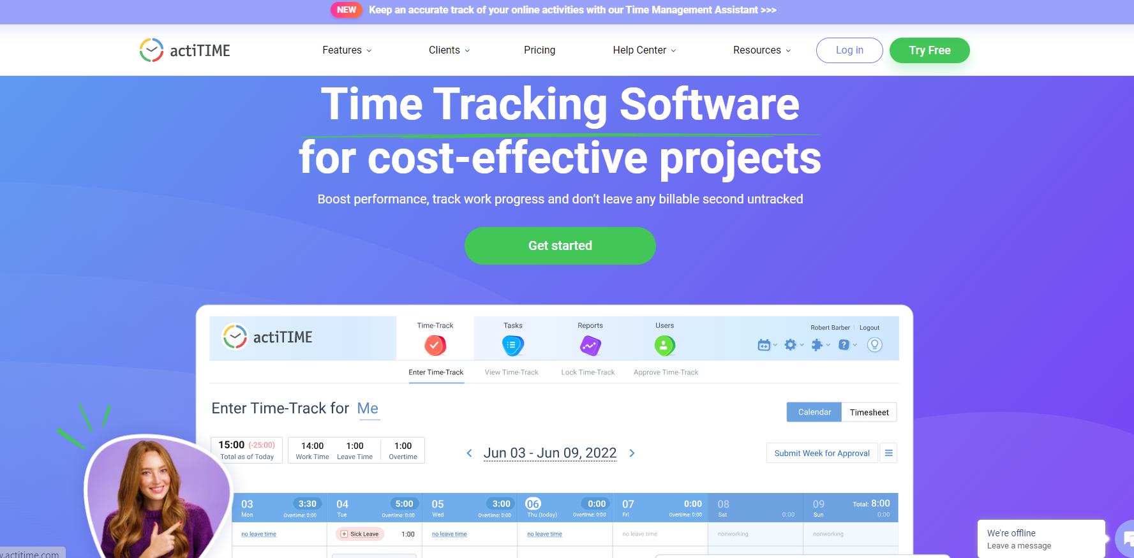

Link: https://www.actitime.com

**Project Flow:**

* User can register and use the actiTIME application for free for 30days
* User can register once and login using credentials and security code received to email provide at the time of registration
* User can chat with customer representative for any queries
* User can also generate reports from actiTIME application about logging hours

# Modules Structure:

We have different modules in this all the modules are listed below,

* Features
  + Time Tracking
  + Billing & Invoicing
  + Customer Care
  + Reports & Data Analysis
  + Team Management
  + Integrations
  + Project Tracking
  + Workflow
  + Product Datasheet PDF
  + See all features link
* Clients
  + Architecture
  + Education
  + IT
  + Consulting
  + Engineering
  + Small Business
  + Design
  + Healthcare
  + Case studies
  + See all industries link
* Pricing
* Help Center
  + User Guide
  + FAQ
  + Admin Guide
  + How-to-Videos
  + API Guide
  + actiTIME Tips
* Resources
  + Guides by topic
  + Time Tracking
  + Project Costs
  + Guides by Industries
  + For Developers
  + For Architects
* Login
* Try for free

# Milestone 1: Features Module

## Activity 1: Features module is having some sub modules and it’s a first module Gold Mine text verification in terms of color ,font ,spacing between words, design

## 

Link: https://www.actitime.com

## Activity 2: Time Tracking page text elements verification in terms of color ,font ,spacing between words, design, alignment

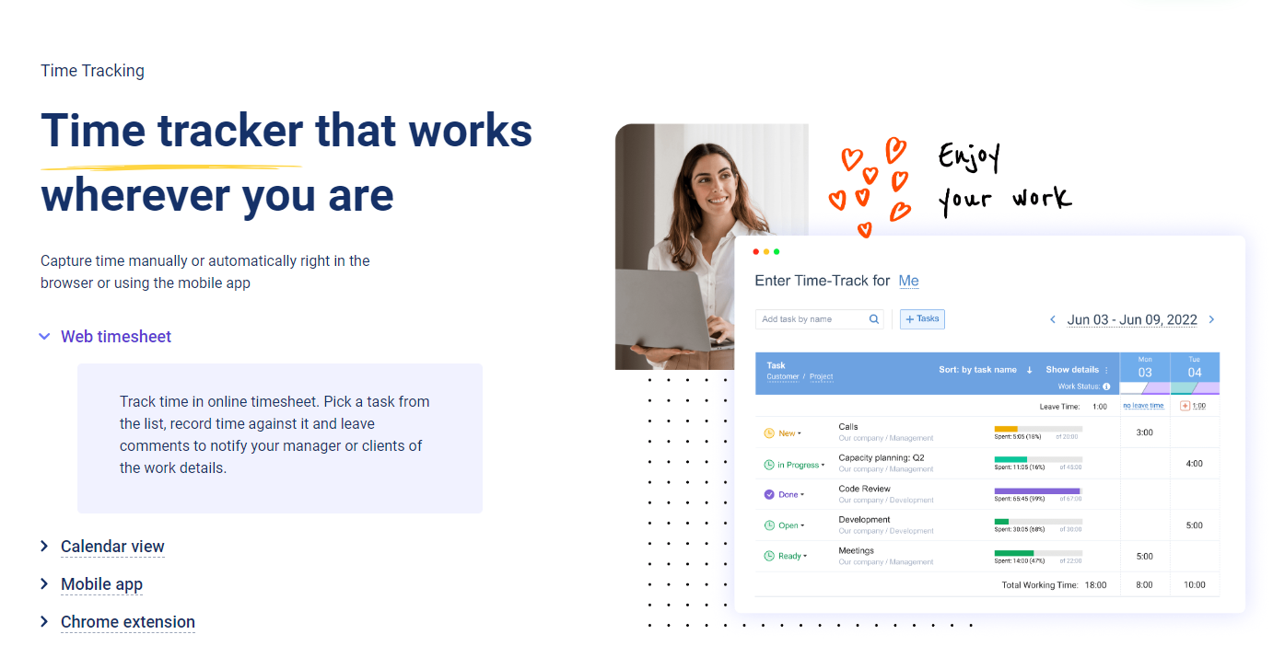

## Activity 3: Verifying Start Using actiTIME button functionality and other text of page in terms of color ,font ,spacing between words, design and alignment



# Milestone 2: Clients Module

Under Clients Module we have different clients for whom actiTIME application is suitable for and it also shows different categories of job roles who get benefit from

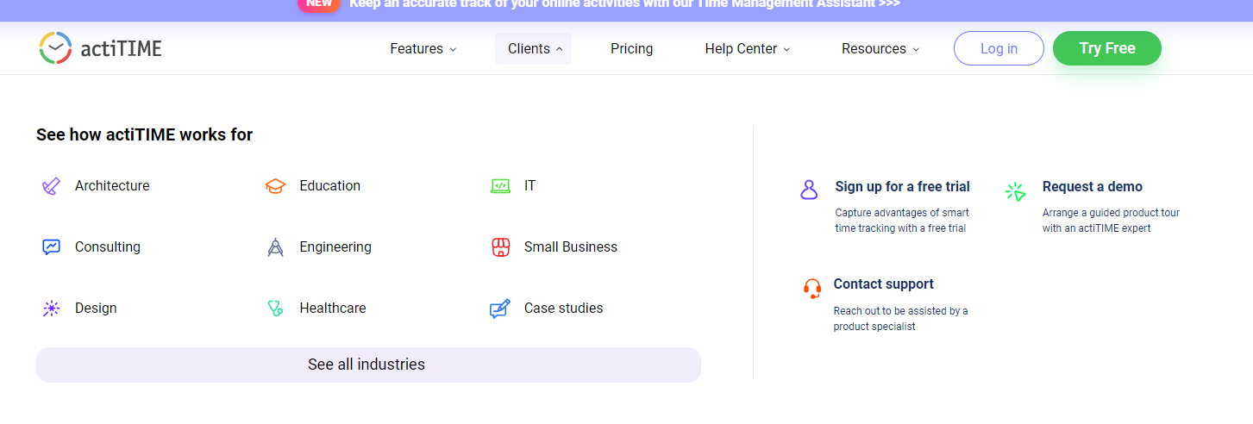

Link: <https://www.actitime.com/>

## Activity 1: Verifying architects page functionality and text in terms of color ,font ,spacing between words, design and whole representation

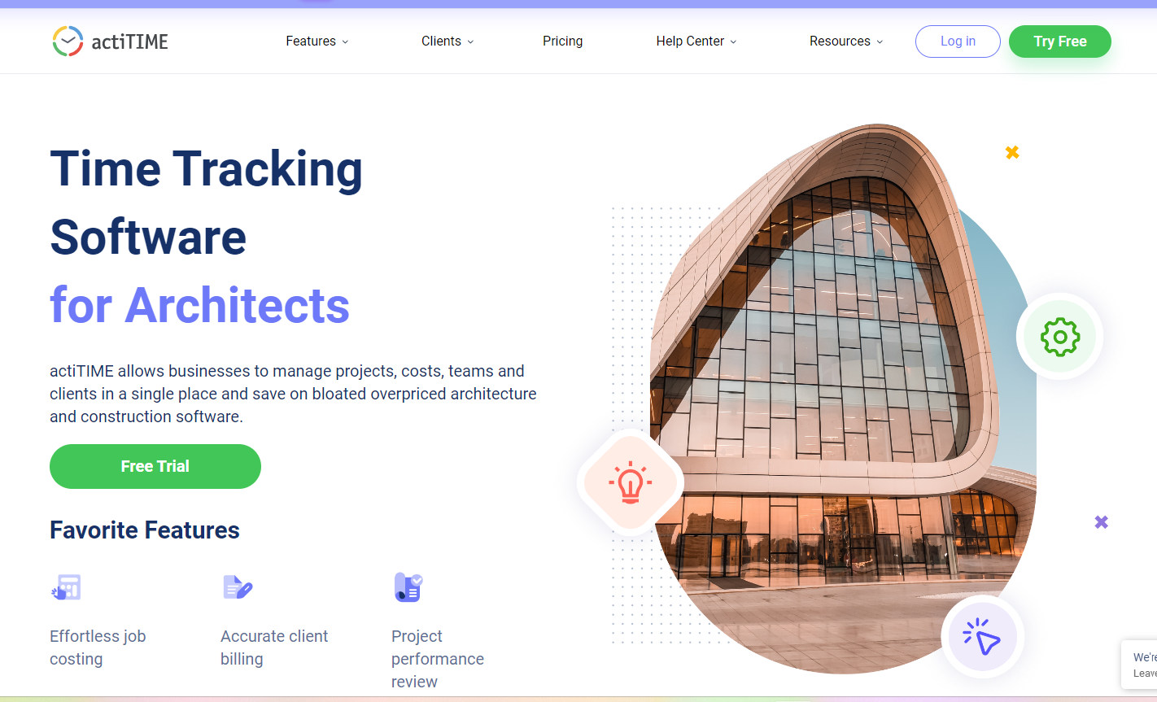

Link: <https://www.actitime.com/testimonials/timesheet-for-architects>

## Activity 1.1: Verifying Free trail button functionality and button in terms of color ,font ,spacing between words, design and alignment

## 

# Milestone 3: Verifying Login page functionality

## Activity 1: Verifying login page functionality and UI elements on the page

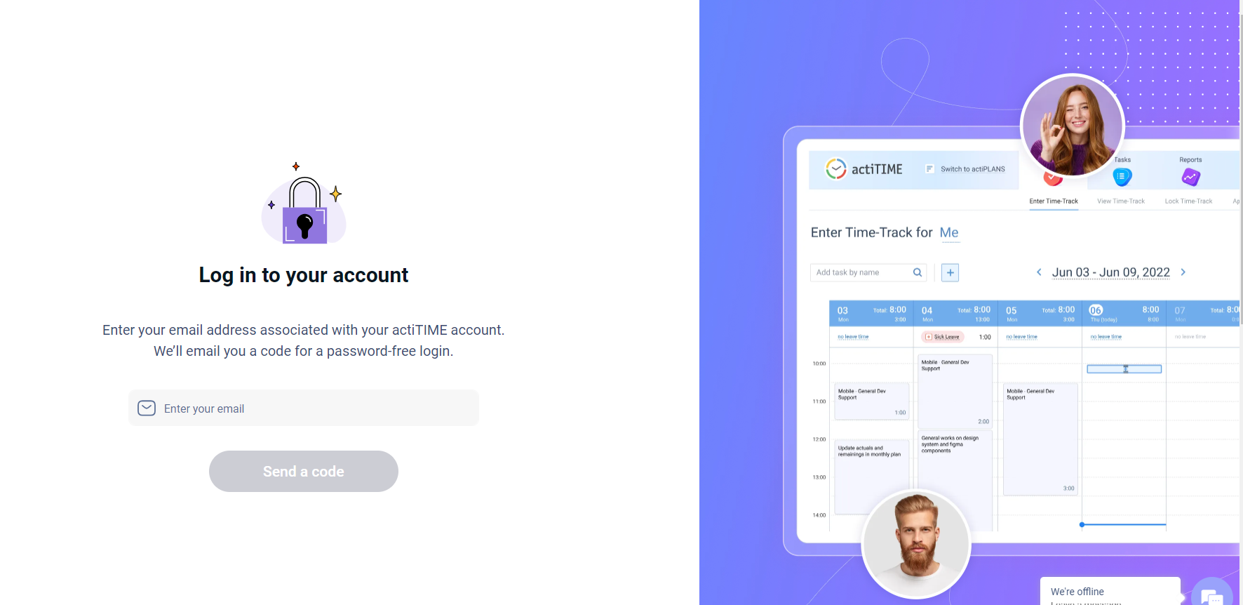

**Link:** <https://www.actitime.com/login-to-product>

## Activity 1.1: Verifying user is able to enter email id and Rings sub modules like Popular Ring Types and all links are redirecting to pages or not and all links are clickable and having any tags beside to existing types



**Link:** <https://www.actitime.com/login-to-product>

## Activity 2: Verifying Send a code button functionality and behaviour of functionality when user entered email id and without entering email id



**Link:** <https://www.actitime.com/login-to-product>

# Milestone 4: Verifying Try free button functionality

## Activity 1: Verifying user is able to click on Try free button and able to see button on top right corner

## Verify user is able to see color ,font, and words alignment of ‘Try free’ text



Link: <https://www.actitime.com/>

## Activity 2: Verifying user is able to enter code received for registered email id and enter and continue functionality

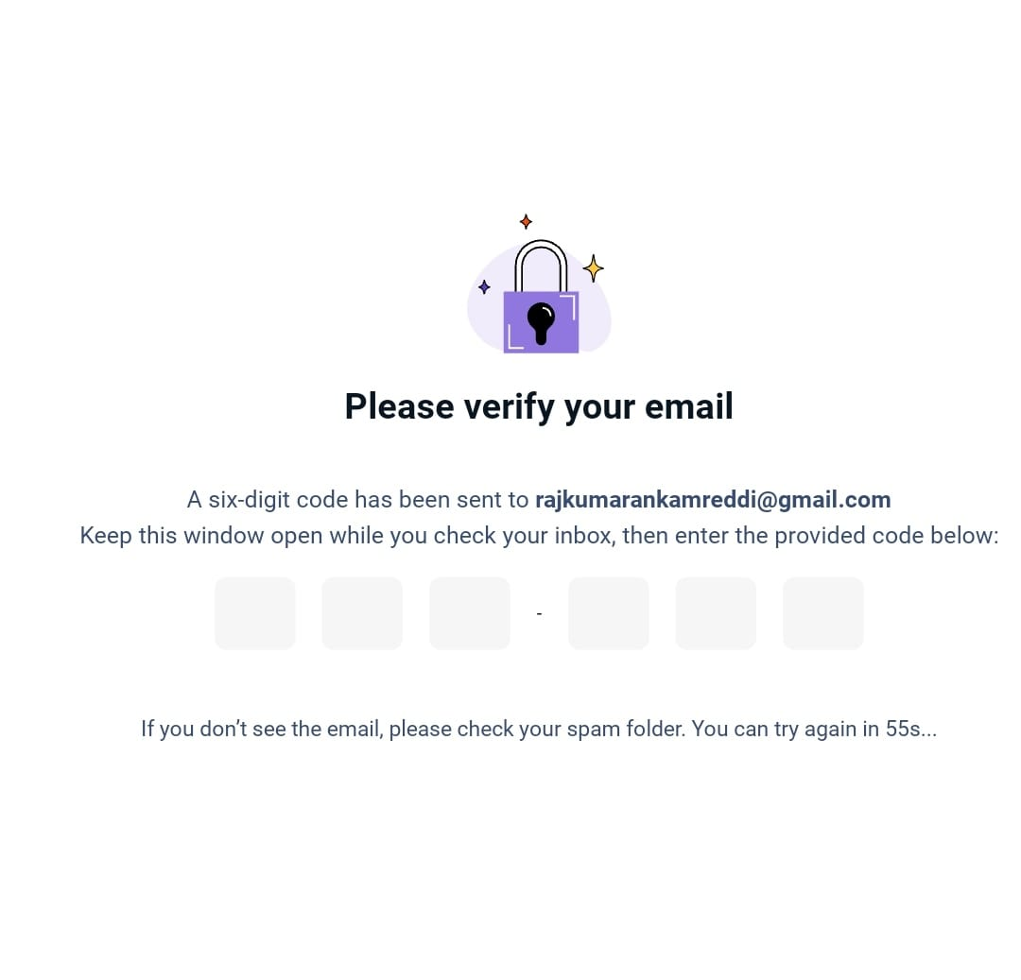

## 

## Link: <https://www.actitime.com/login-to-product/check-email>

## Activity 3:Received an email with code below that needs to be entered and continue verify user is able to enter code and able to continue

## 

# Milestone 5: Verifying Time tracker page functionality

## Activity 1: Verifying user is able to enter time for a selected week and verify text color ,font, and words alignment

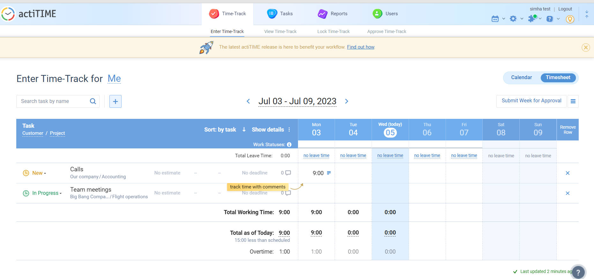

Link: https://online.actitime.com/simha/timetrack/enter.do

## Activity 2: Verifying user able to enter any activity name and able to select suggested list and click on “+” symbol to add to time tracker for that week

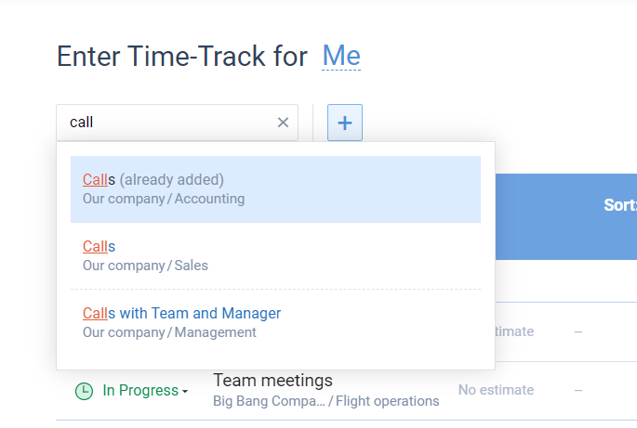

Link: <https://online.actitime.com/simha/timetrack/enter.do>

## Activity 3: Verifying user able to change status of the tasks like New, Planning, In Progress, Review etc..

## 

Link: <https://online.actitime.com/simha/timetrack/enter.do>

**Final Testing Areas:**

1. Test the Home page elements color, font, alignment, design
2. Test the Login, Try Free button functionalities
3. Test the login functionality with valid & invalid code
4. Test user is able to search activity with global search and add
5. Test user is able to enter time in hours in week/day wise
6. Test user is able to switch between calendar & Timesheet
7. Test user can change weeks
8. Test user can track time & Tasks
9. Test user can change status of any existing task

10.Test user can change settings any point of time